Ganache:
It is used to create local Ethereum network and it also gives local network test accounts with fake ethers.
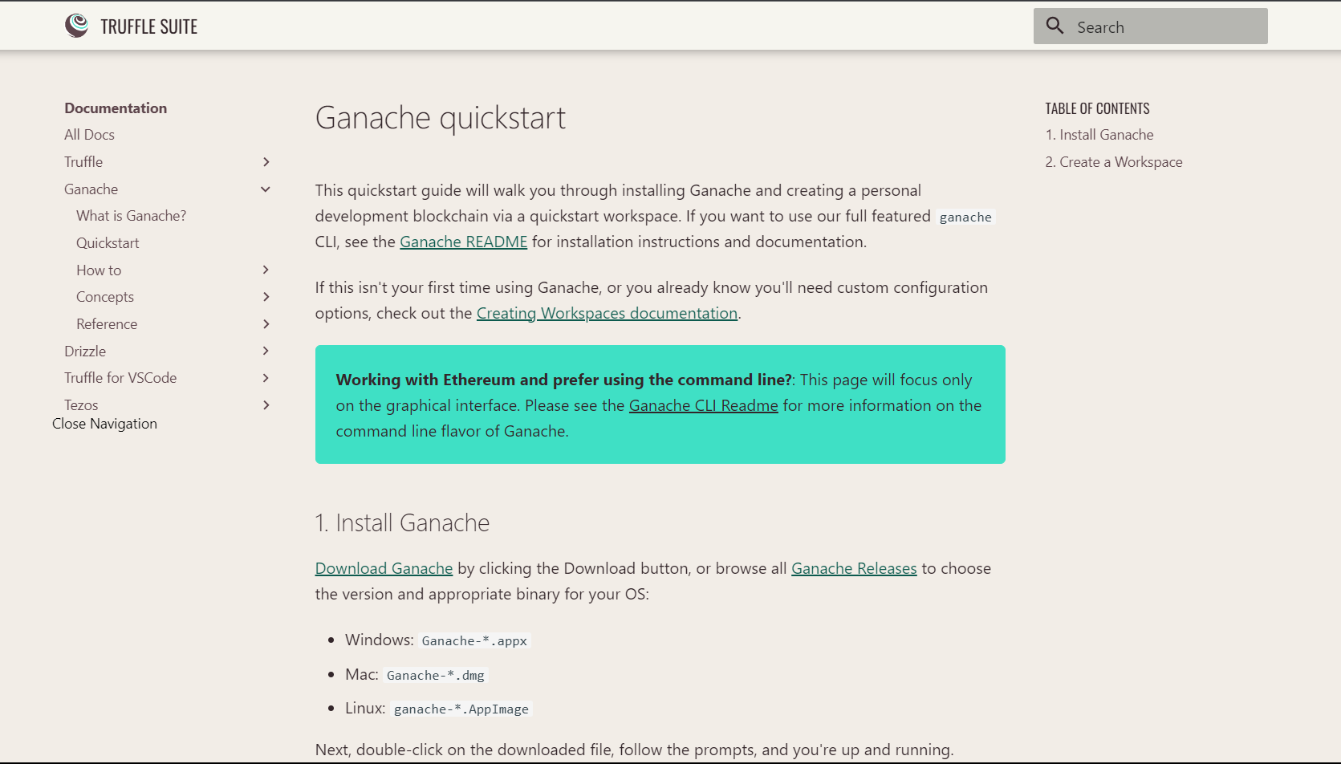

For more info.: https://trufflesuite.com/docs/ganache/

Researching MetaMask
It is a blockchain wallet that can perform transaction in cryptocurrencies and can also run in test networks.
